6th Summer Camp of Rhetoric
and Democratic Education 2022

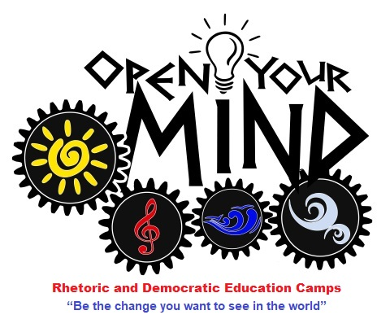

Open Your Mind Camp 2022

Corfu, 7-12 / 7/22

Inspired by the Summerhill Festival of Childhood 2022 (https://summerhillfestival.com/)

CAMP PRESENTATION - INVITATION TO PARTICIPATE

After a successful five years of camps in the Cyclades (https://openyourmindcamp.weebly.com/), in which about 350 high school students from all over Greece have participated and for which more than 150 experiential workshops have been specially designed and implemented, the Rhetoric and Democratic Education Camp "opens sails" for the Ionian. It is addressed to high school students and graduates aged 15-18 from Greece and abroad (Greek schools abroad, classical high schools, democratic schools in Europe). 50% of the participation will come from the Ionian and neighboring regions. 20% from areas outside Athens and 30% from Athens. The aim is to diffuse the contents of the camp as much as possible.

This year's program remains focused on the triptych "personal development - acquaintance with the culture of the place - entertainment" and acquires a specific theme: "The arts in the cultivation of skills of an active citizen."

The main organizer this year is as every year the Hellenic Association for the Promotion of Rhetoric in Education (www.rhetoricedu.com). The design, as in previous years, is based on the concepts of "Thought - Speech - Action", as well as on principles of democratic education, such as equality and mutual respect. Participants learn to express themselves freely, to reflect on issues they consider important, to respect the views of others, to devise strategies to solve problems, to collaborate and to use their social creativity. Particular emphasis will be placed this year on developing ties and encouraging voluntary initiatives during and after the camp.

Spring Academy (https://springacademy.gr/) is the co-organiser of the camp, an alternative educational structure based in Corfu, and the Postgraduate Program of the National and Kapodistrian University of Athens "Rhetoric, Humanities and Education", the European Democratic Education Community (EUDEC-Greece), "Afixis" - Virtual Trials "Protagoras", the Rhetorical Club-School of Philosophy-National and Kapodistrian University of Athens - are supporters. The facilitators will be graduates of the Postgraduate Rhetoric and Research Pedagogical Team "Sirios" this year again, as well as Spring Academy educators.

The camp is expected to soon receive the auspices of the Municipality of Corfu and to have a creative collaboration with the Ionian University, the branch of the National Gallery, where daily workshops will be held, and the branch of the Panhellenic Network for Theater in Education.

This year's program includes:

a) the daily acquaintance of the participants with the nature and the culture of the island (excursions to town, villages / beaches, hiking, visits to museums, traditional nights, information from local cultural institutions, recreational evening outings etc. ), and

b) the main activity of the camp, which is the participation in a variety of daily three-hour experiential personal development workshops, which will be selected daily via electronic form and based on availability: rhetoric, communication, youth leadership, creative writing, video / short film creation, conflict resolution, human rights, creative thinking, virtual trials, philosophical debates, debates, TED talks and public speaking, spontaneous speech, expressive reading, improvisation, modern and traditional dance, rhetoric of image and graffiti, etc., but also additional suggestions from the participants themselves. You will be given the opportunity to attend two intensive 6-hour workshops (2 out of 5 days): "Escape Room Academy" (design and implementation) and "Debating Camp" (argumentation methodology and rhetorical argument - friendly matches). If there is a sufficient number of participants (minimum 8 people), an English-speaking group will be created.

The workshops for teenagers will be announced in detail on 25/6 and the participants who have already registered will be able to choose everyday through a form what they wish to attend. Attendance in the experiential workshops (total duration 15 hours) is the basic part of the camp (unless there is a health reason for not participating in a specific day) and is certified by a detailed certificate. Voluntary involvement in the organization of the camp can also be certified, if one wishes to participate as a volunteer.

The camp will be hosted at Karda Beach Camping and Bungalows (http://www.kardacamp.gr/) in Dassia, in an excellent and safe environment.

The cost of participation only in the workshops is 60 euros, if a student wants to participate (from Corfu) only in these. Please contact us for possibilities of funding. The cost of accommodation, food, transportation, etc., which is exclusively to cover the operating costs of the camp, as all facilitators and organizing team are volunteers, amounts to 300 euros and includes the following:

· 5 nights in a tent of your own and with your own camping equipment - It is possible to stay in a 4-bed bungalow (6-7 will be available in total with strict priority) at an additional cost of 60 euros or in a 4-bed large tent (with beds, electricity, refrigerator - 2-3 will available in total with strict priority) at an additional cost of 40 euros.

· Partial food provision: breakfast buffet daily, 2 meals (cooked with salad / soft drink / sweet or fruit), 50% discount on 2 dinners (souvlaki, pizza with soft drink), afternoon snack (breadsticks / crackers / cereal bars / chocolate cream, toasty / cookies / cake of your choice) during the workshop break.

· Coach tickets to and from Athens - boat from Igoumenitsa - transfer to and from the port with Green Buses (https://greenbuses.gr/).

· 2 bus trips within the island

· Souvenir T-shirt and gift

· Special discounts in shops and restaurants

· Certificate of participation

· Membership in the Youth Network for Democracy in Education (after completing a relevant application) and attending the relevant events within the next school year

Registrations will be completed on 15/6/21, with a non-refundable deposit of 160 euros, for the reservation of tickets and accommodation (the IBAN of the campsite and the collaborating tourist office will be sent). Strict order of registration priority will be observed.
Registration form: https://forms.gle/YhrxWvWHQWxzrrBQA
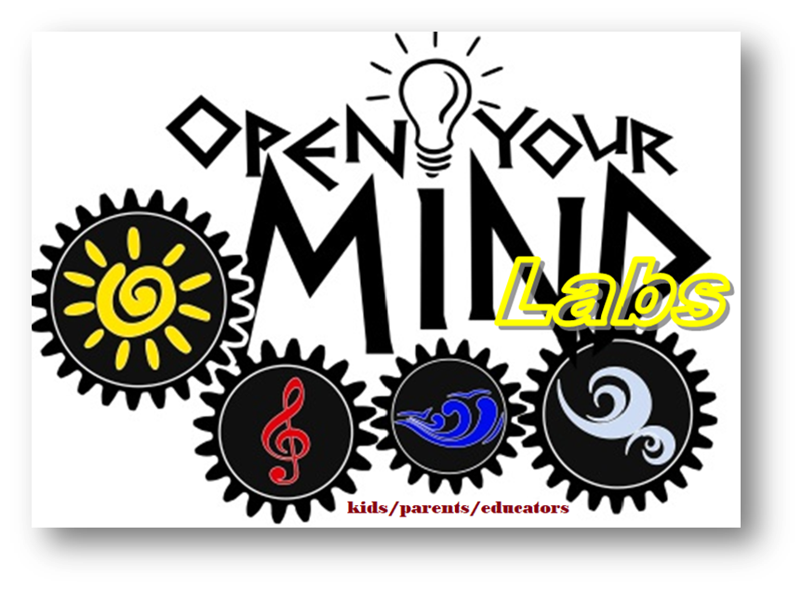
In addition, from this year Open Your Mind Labs is inaugurated at the site of the Spring Academy (Casa Lucia) from 9:00-14:30 for two groups:

a) Creative Team of Children and Parents “Learn2Fly Lab”

b) Group of Teachers for Experiential Education “Learning by Experience Lab”:
which will be a separate group with workshops lasting 15 hours, which will be pre-determined by joint consultation between nominees.

You can see details and the program here.

The minimum number of participants to run each workshop is 6 people. The participation cost is 80 euros for 6 days, 20 for one day and 10 per workshop.
Registrations by 25/6/22 here.

More information: enosiritorikis@gmail.com and by SMS to 6944414077

The organizing team will strictly apply the health protocols that will be in force during the implementation period of the camp.

